**Create table travel data:**

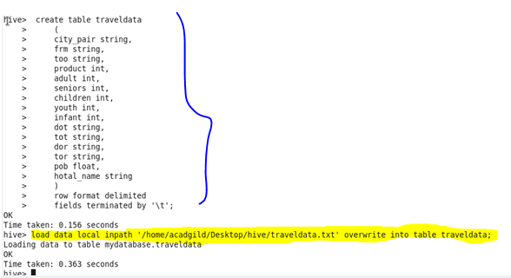

**1.Write a hive query to find the top 20 destination people travel the most:**

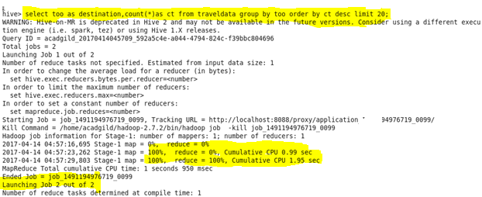

**Output:**

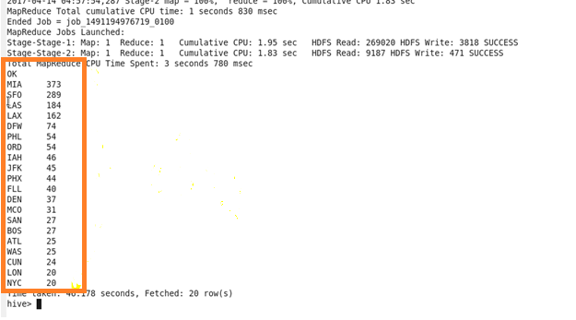

**2.Write a hive query to find the top 20 locations from where people travel the most:**

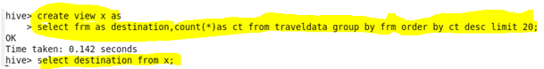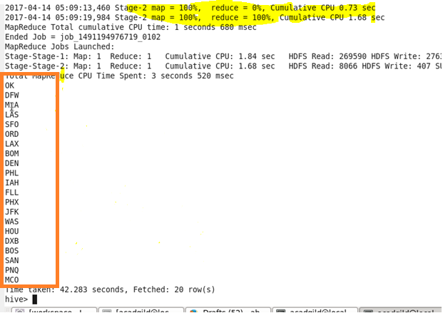

**Output:**